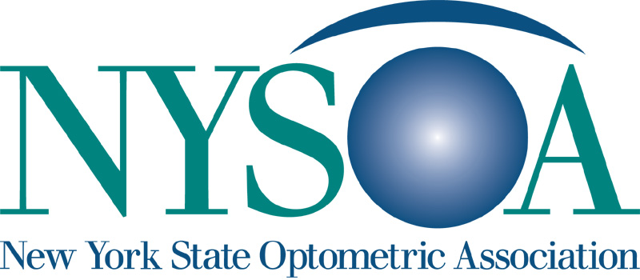

Membership Application

Name Referred By

Sex: Male Female
Date of Birth

Home Address City State Zip

Telephone Email

Business Address (Please include the business name) City State Zip

Business Telephone Fax

Preferred Mailing Address: Home Business

You are joining the Local Society in which you: Live Work

New York State License Number Original Date of New York State Licensure

Are you licensed to practice in any other states? Yes No Please list:

Number of years in practice Number of hours worked per week

Are you a member of any other optometric societies? Yes No

If so, please list:

Are you transferring from another state association? Yes No

Optometry School Attended Graduation Year

Did you complete a residency? Yes No Year:

Are you a faculty member of SUNYCO? Yes No

*If the answer to the above question is yes please answer the following questions:

Position held at SUNYCO?

Description of responsibilities?

Is your spouse a current member? Yes No Name:

Has your certificate of registration ever been revoked, annulled or suspended? If Yes, please attach a letter of explanation Yes No

Referral Listing:

Academy FAAO Contact Lenses General Refractive Surgery
House Calls Low Vision Sports Vision Vision Therapy
Medicaid Medicare DPA Certified TPA Certified
TPA 2 Certified

To the Secretary of
The New York State Optometric Association, Inc.

I, am applying for membership in the Optometric Society, the New York State Optometric Association, Inc., and the American Optometric Association. I agree to abide by the Constitution and By-Laws, and to adhere faithfully to the Code of Ethics of the New York State Optometric Association, Inc. and the American Optometric Association.

Signed
Name in Full

Date of Application:

Upon approval of membership application, a dues statement will be sent to you at your preferred mailing address. Monthly or quarterly dues payments are available upon request.

